Sprint 1 Summary - Sustainability Gamification App
Overview
Sprint 1 focused on building the foundation of the Sustainability Gamification App, implementing essential features, and addressing initial technical challenges. The primary goal was to establish user authentication, gamification mechanics, and the groundwork for future expansions.

1. Work Completed
1.1 System Architecture & Database Design
- Established a Model-View-Template (MVT) architecture using Django.
- Designed and implemented database models for user authentication, points, quizzes, and restaurant check-ins.
- Created a structured approach for managing user profiles and sustainability-related data.
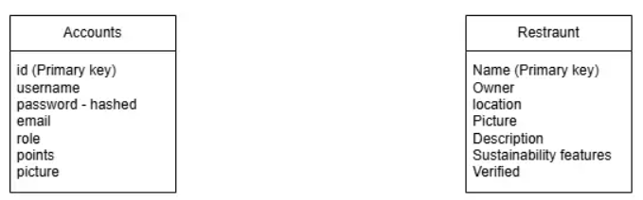1.2 Core Features Implemented
- User Authentication:
  - Registration and login system implemented using Django’s built-in authentication.
  - Custom user profiles created to store sustainability points and additional data.
- Gamification & Points System:
  - Users earn points for completing quizzes and check-ins.
  - A Leaderboard ranks users based on their total points.
- Sustainability Quiz:
  - Users can answer sustainability-related questions to earn points.
- QR Code Check-In System (Prototype):
  - Users can check into predefined locations (though mobile scanning is still under development).
- Restaurant Listings:
  - Admins can add verified sustainable restaurants to the database.

🚧 2. Challenges Faced & Solutions
2.1 Implementing the Quiz System
- Initially followed an online tutorial to create the quiz system.
- Struggled with adapting it to the project’s unique requirements.
- Faced difficulties working across multiple operating systems (Windows, Linux, and laptop setup).
- Eventually integrated quiz points with another team member’s UI.
2.2 Passing User Profiles to Relevant Pages
- Encountered issues ensuring user profiles were correctly passed to search results, editing pages, and other linked forms.
- Required retrofitting URLs and adjusting forms to accommodate profile data properly.
- Successfully resolved through updates to URL routing and form handling.
2.3 Styling Login & Registration Forms
- Django’s auto-generated forms (from forms.py) were difficult to modify with basic HTML & CSS.
- Customization is still in progress, requiring more control over form rendering.
2.4 QR Scanner Limitations
- QR scanner works successfully on PC browsers but does not function correctly when accessed via mobile devices.
- Further development is needed to ensure cross-device compatibility.

🔮 3. Future Plans for Sprint 2
3.1 Feature Expansions
- Improve points & rewards system, including new ways to earn points.
- Implement verified check-in system using QR codes for sustainability locations.
- Expand the challenge system to include more interactive sustainability tasks.
3.2 UI/UX Enhancements
- Improve design and styling for login, registration, and leaderboard.
- Add animations and user-friendly layouts for better engagement.
3.3 Testing & Security
- Expand test coverage for login, quiz, and leaderboard.
- Ensure GDPR compliance with secure data handling and user consent mechanisms.

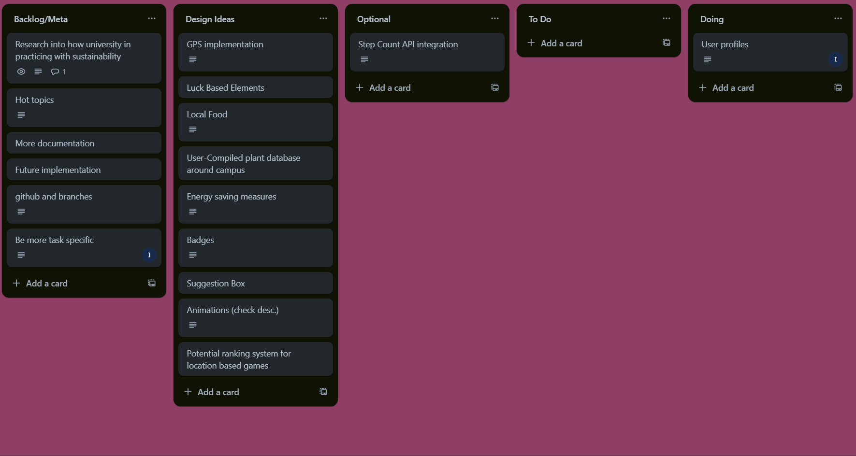
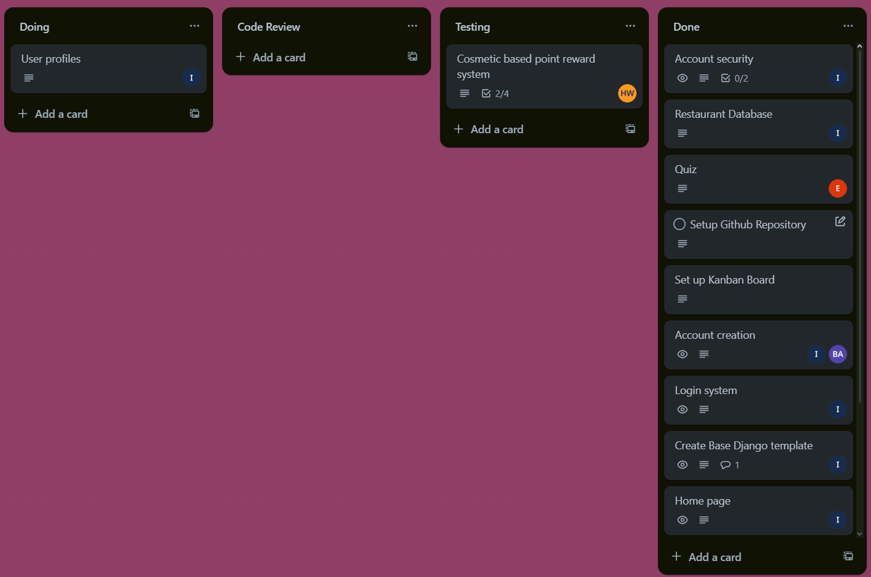
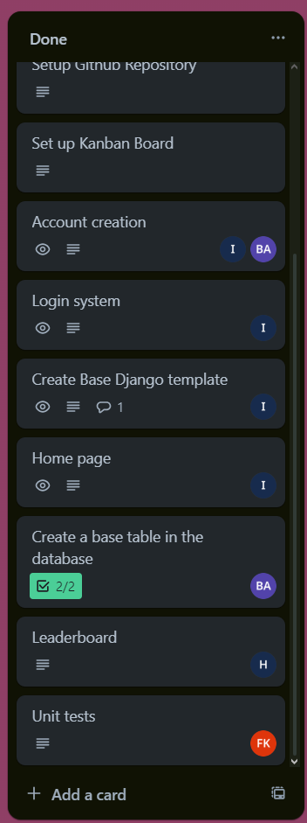
Sprint 1 has successfully laid the foundation for our sustainability gamification platform. Future sprints will focus on refining features, improving UI/UX, and enhancing overall functionality.

